THEORY QUESTIONS
1.
(a)

In a class of 39 students, 19 offer French and 25 offer Ga. Five students do not offer any of the two languages. How many students offer only French?
(b)

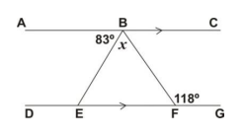
In the diagram above, AC is parallel to DG, angle BFG = 118° and angle ABE = 83°.
Find the value of
(i)

angle CBF;
(ii)

x.
(c)

A fair die is thrown once.
(i)

Write down the set of all the possible outcomes.
(ii)

Find the probability of obtaining a multiple of 2.
(iii)

What is the probability of obtaining a prime number?

2.
(a)

A water tank in the form of a cuboid of height 22 cm and a rectangular base of length 7 cm and width 5 cm is filled with water. The water is then poured into a cylindrical container of diameter 14 cm.
Calculate the height of the water in the cylindrical container.
[Take π =
22
7
]
(b)

A trader is given 15 percent discount on goods bought from a factory. If the original price of an item in the factor is ₵45,000,000, calculate
(i)

the discount on the item
(ii)

the amount the trader paid for the item.
(c)

Find the truth set of
x - 3
3
≤
1
2
+ x and illustrate your answer on the number line.

3.
Using a ruler and a pair of compasses only,
(a)

Construct triangle PQR such that the length of PQ = 10 cm, angle QPR = 90° and angle PQR = 30°.
Measure the length of PR.
(b)

Bisect the angle QRP to meet PQ at M.
(c)

With M as centre, and radius MP draw a circle.
(d)

Measure the radius of the circle.

4.
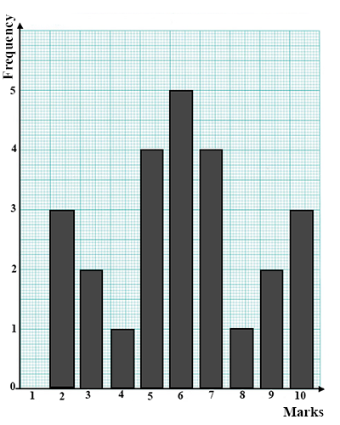
The bar chart above is the distribution of marks in a class test.
(a)

(i)

Write down the frequency table for the distribution.
(ii)

Use the table to find the mean mark.
(b)

If the pass mark is 4, how many pupils failed the test?

5.
(a)

Mr. Jones used 173 units of electricity last month. If the charge for the first 110 units was ₵150 per unit and ₵200 per unit for the rest, calculate the total bill for Mr. Jones.
(b)

Express 4 hours in seconds leaving your answer in standard form.
(c)

Given the vectors r =
(
3
-5
)
and p =
(
-7
-9
)
and q = 2p - r, find q.

6.
(a)

Using a scale of 2 cm to 2 units on both axes, draw two perpendicular axes OX and OY on a graph sheet. On the same graph sheet, mark the x-axis from -10 to 10 and the y-axis from -10 to 10.
(i)

Plot A(2, 2), B(6, 2) and C(4, 6). Join AB, BC and AC
(ii)

Draw the image triangle A₁B₁C₁ of triangle ABC under a clockwise rotation of 90° about the origin, where A→A₁, B→B₁ and C→C₁.
(iii)

Draw the image triangle A₂B₂C₂ of triangle ABC under a reflection in the y-axis, where A→A₂, B→B₂ and C→C₂
(b)

When 12 is added to a certain number and the sum is multiplied by 4, the result is 60. Find the number

